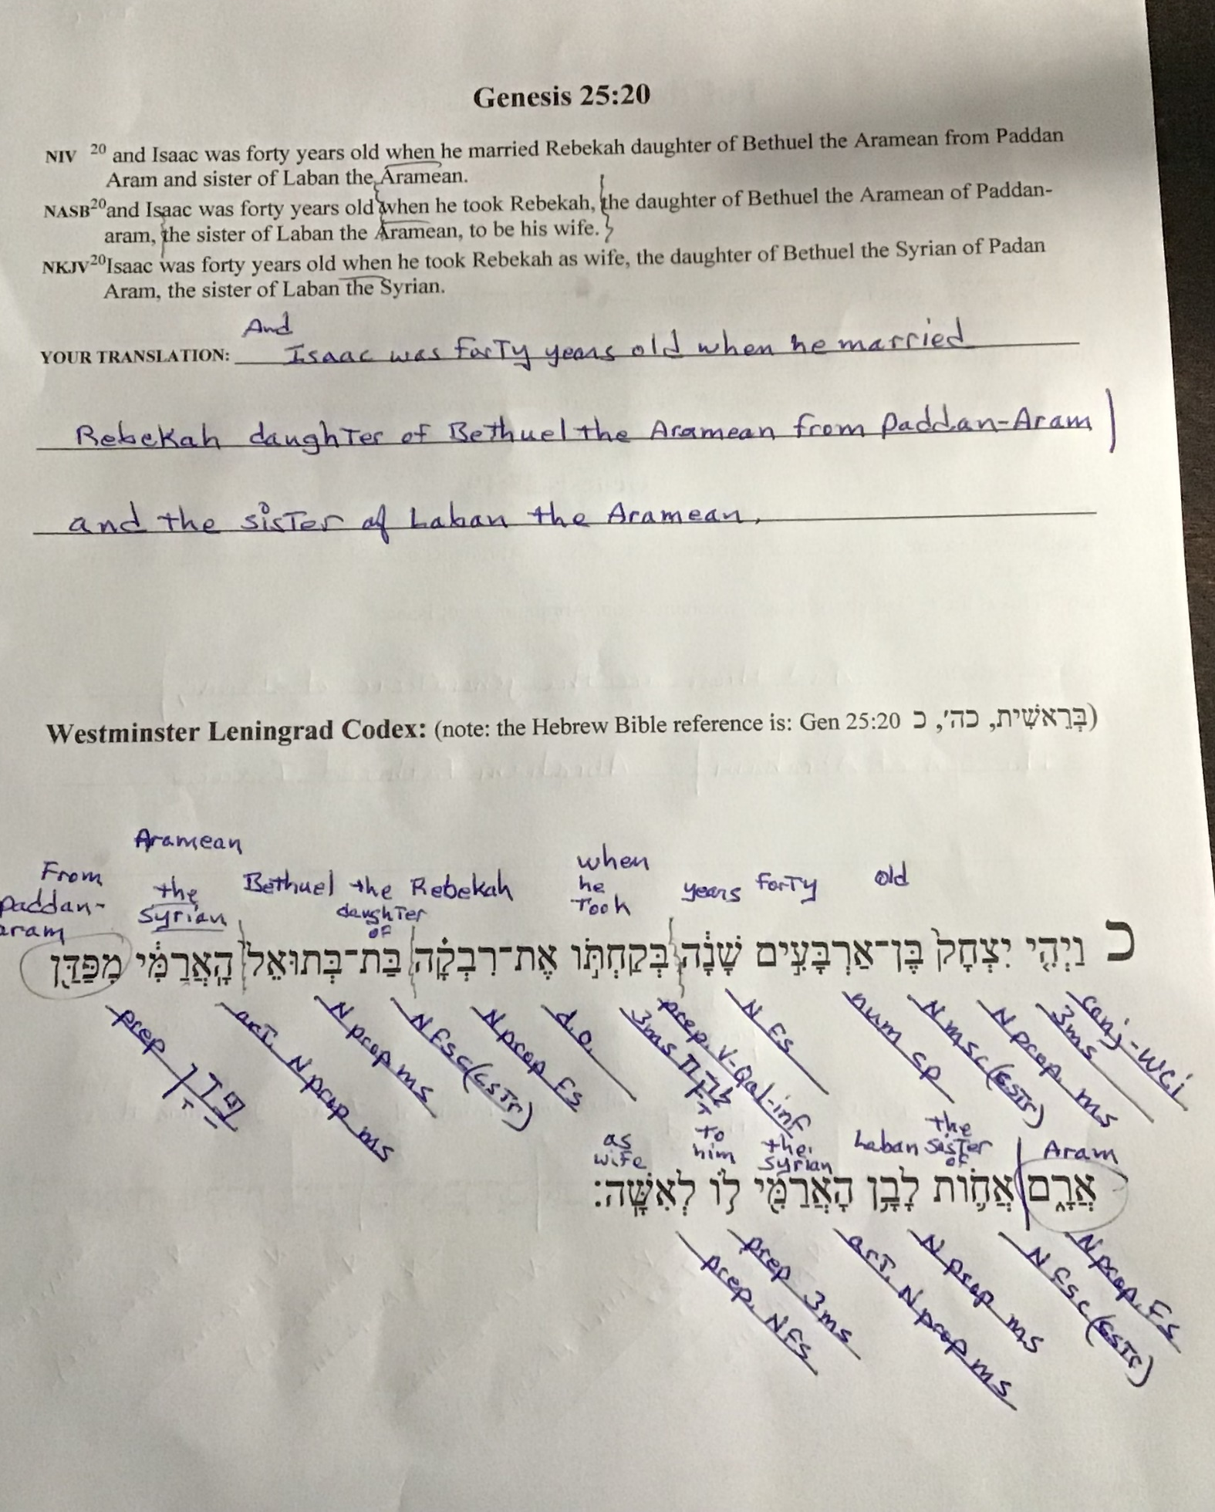
PARSING: wk 6 – Tol’dot – Gen 25:20

